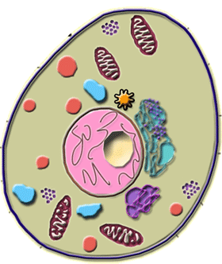

Discovery of Cells

A cell is :_______________________________
_______________________________________
_______________________________________

Complete the following table:

Name | Date | Contribution

